Name: Aarti Patel

STD: TYBSCIT

ROLL NO: 038

SUBJECT: DMBI (Data Mining Business Intelligence)

Practical no 4A,4B

Signature:

**Practical 4A – Create the cube with corresponding dimension and fact table based on OLAP**

Continue from the above practical.

To verify, in SQL Server Management right click on the file name in Object Explorer and click on Browse.

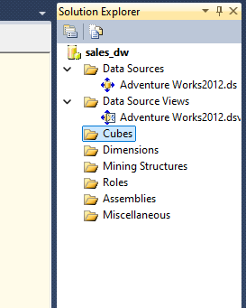

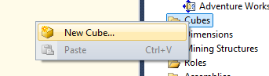

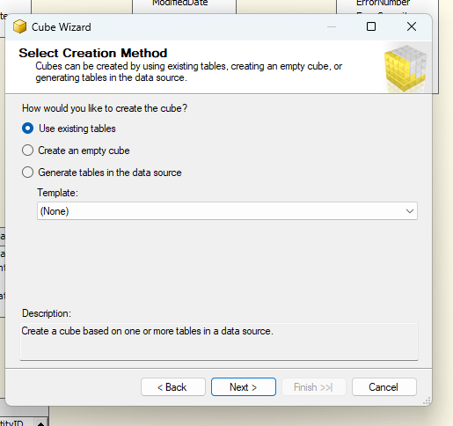

Select the tables

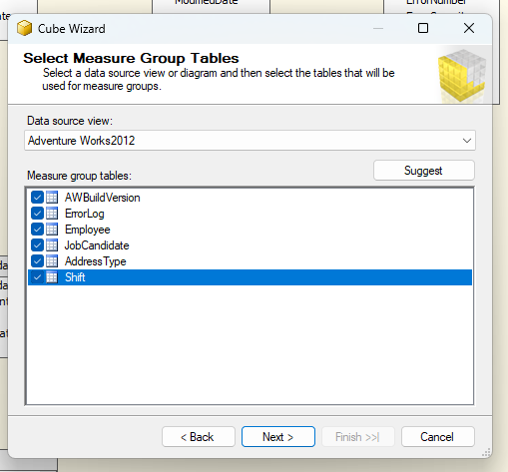

Select all the measures to include in the cube and click on Next.

Select all the new dimensions and click on Next.

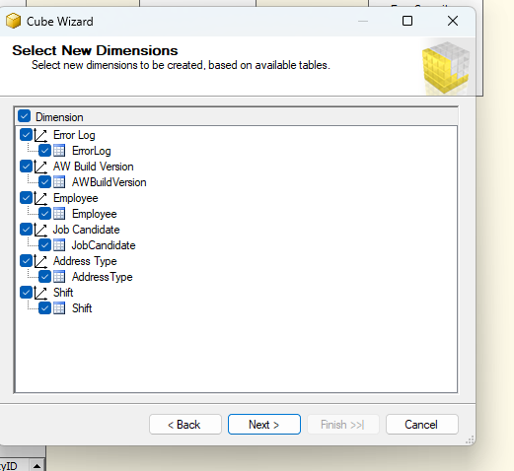

The relationship will be displayed on the screen. 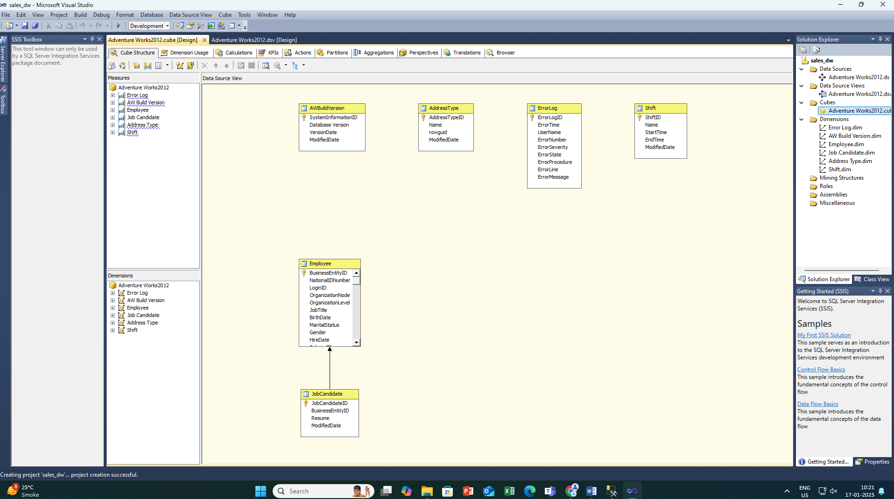

Drag and drop Year, Quarter and Month to the Attributes.

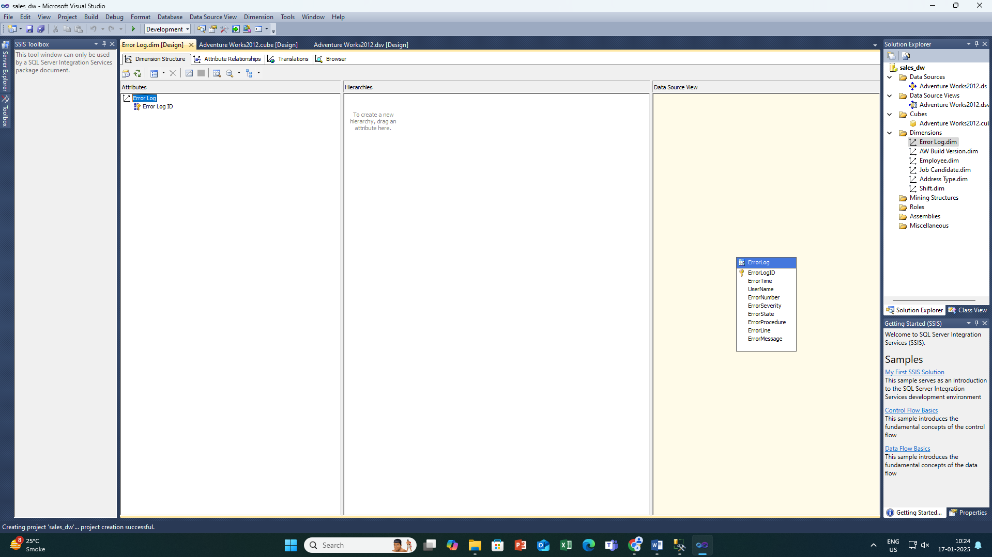

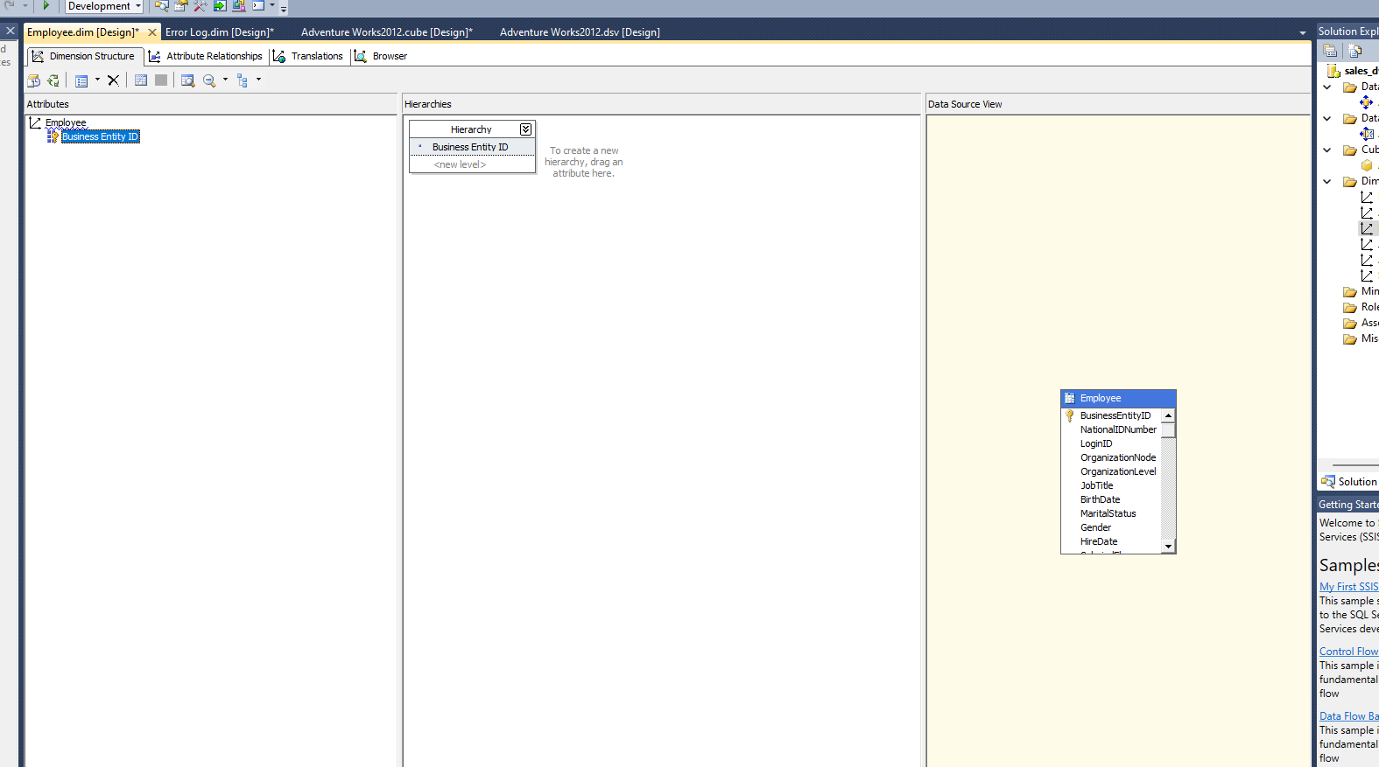

Save the progress and click on OK.

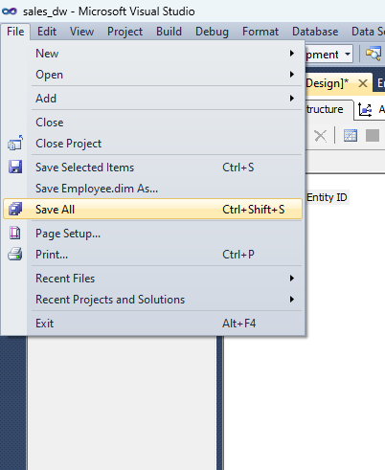

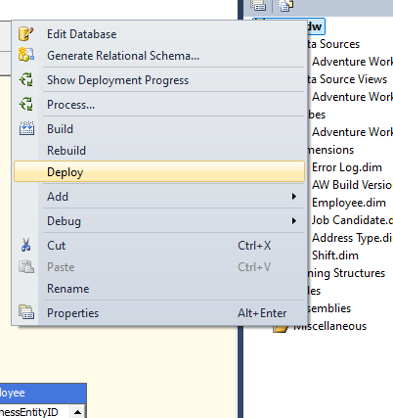

At the bottom of the screen it is shown that the deployment is successful.

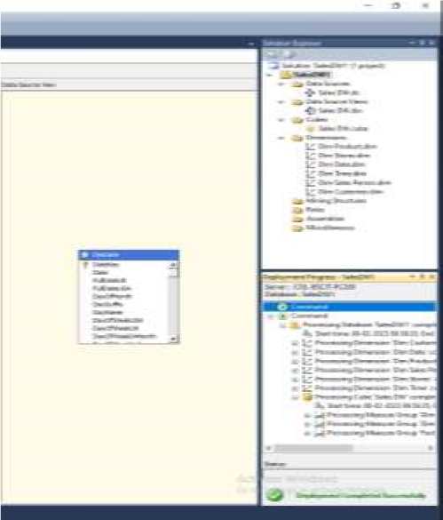

**Practical 4B – Perform Multi-Dimensional Expressions (MDX) queries for**

**OLAP database**

Continue from the above practical.

To verify, in SQL Server Management right click on the file name in Object Explorer and click on Browse.

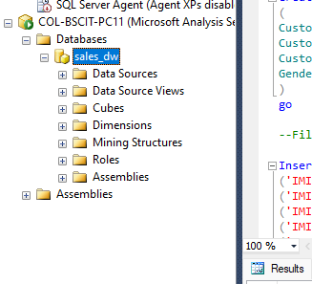

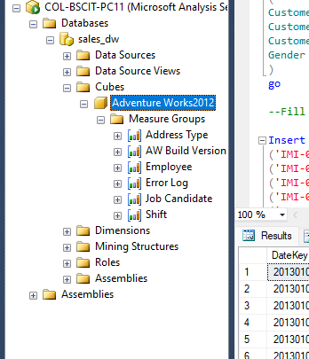

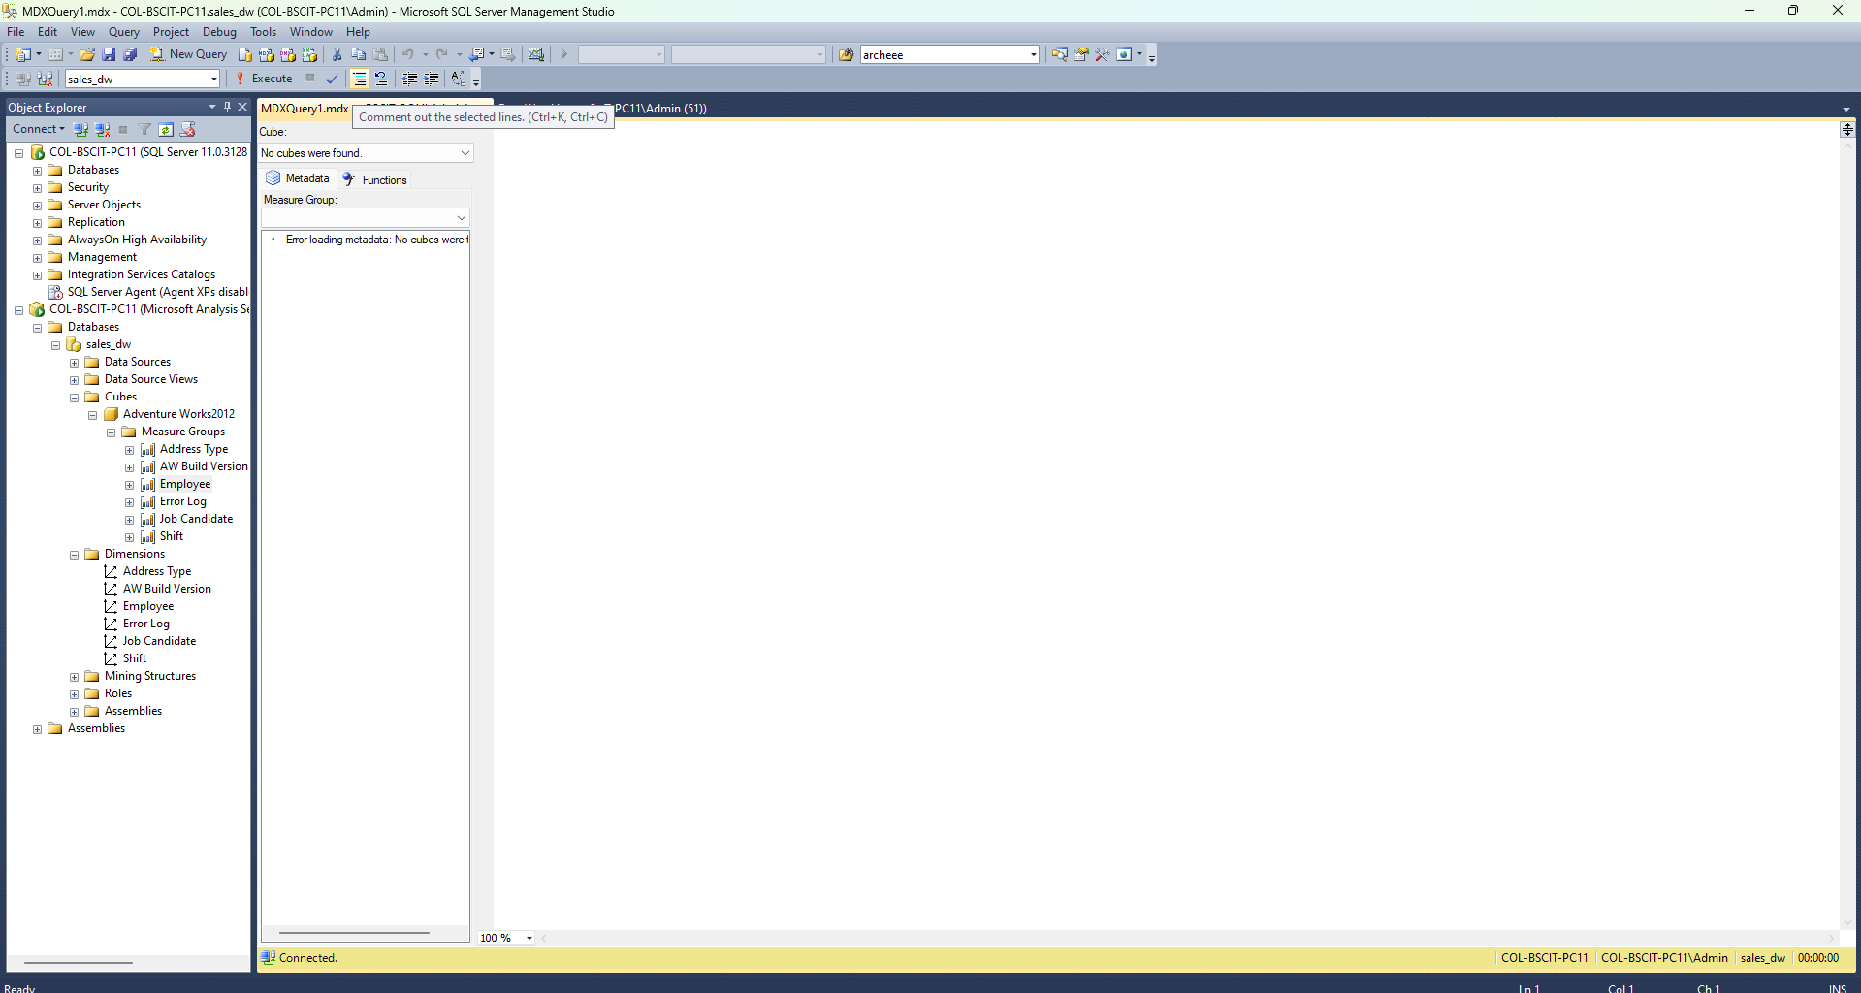

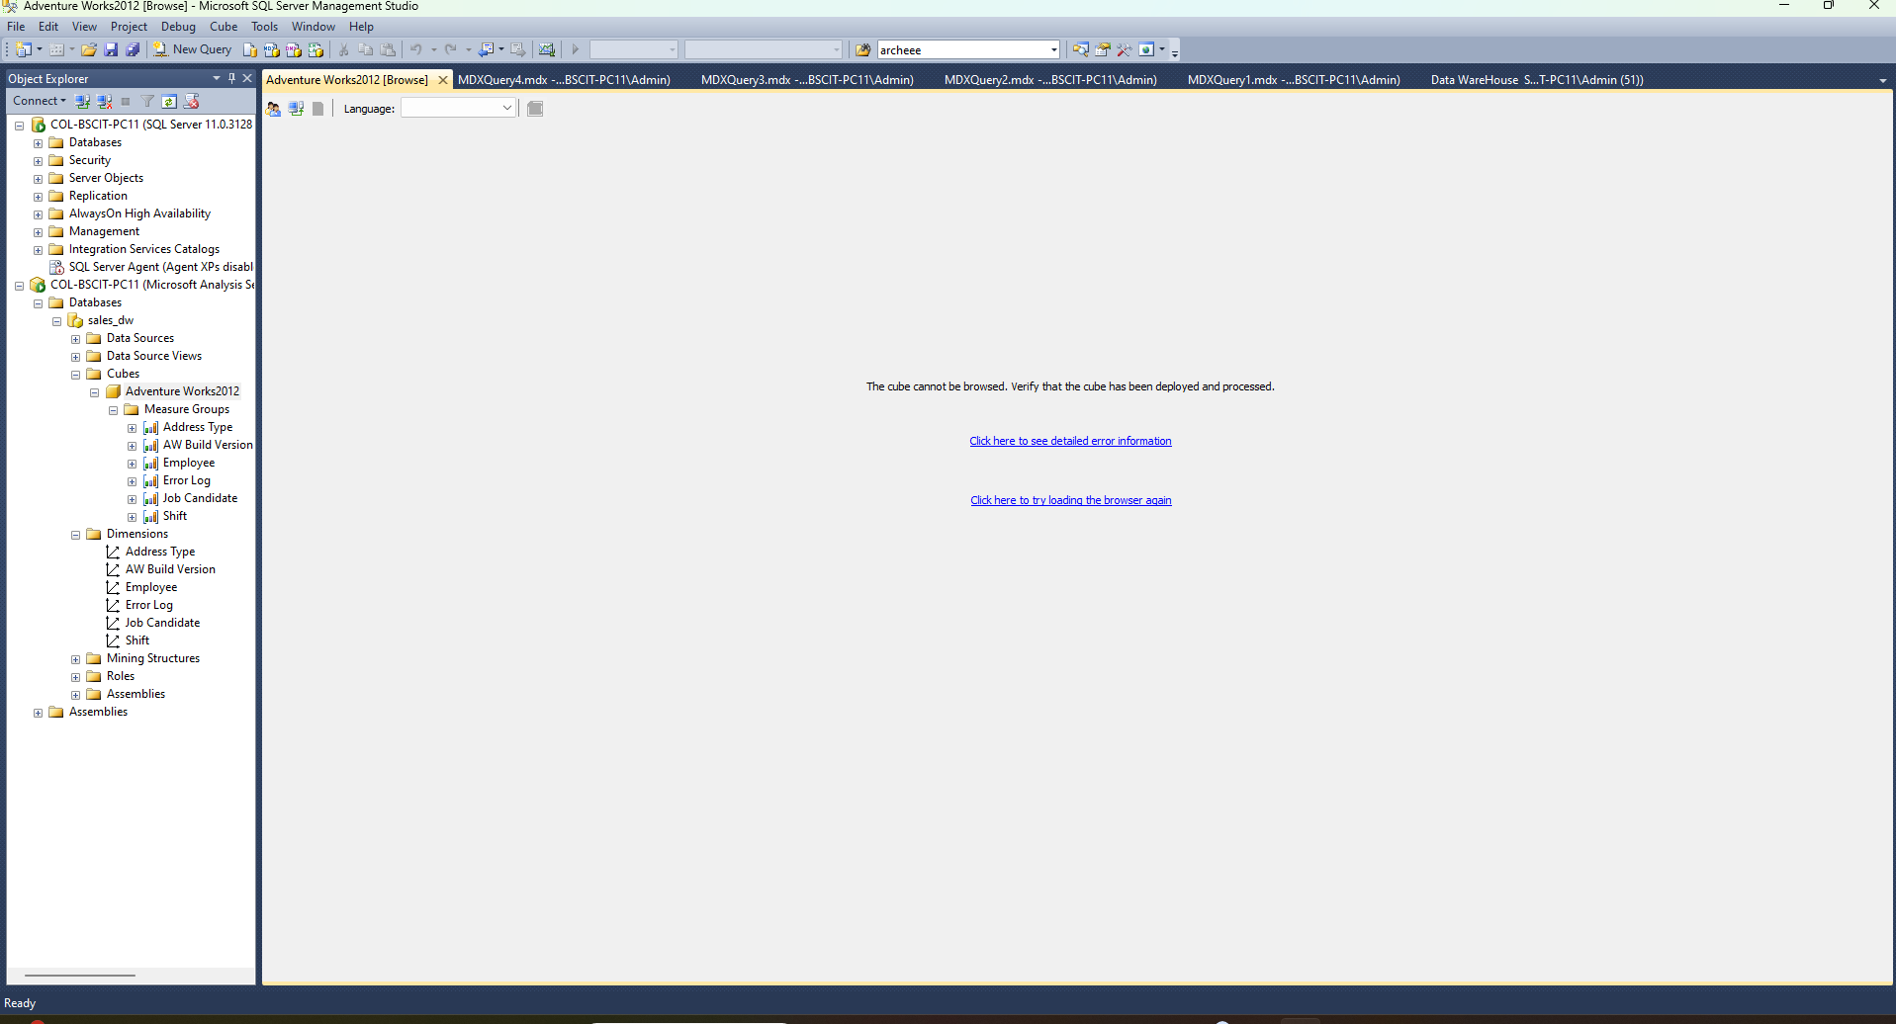

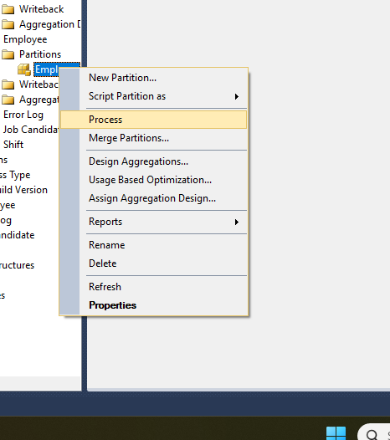

Click on OK.

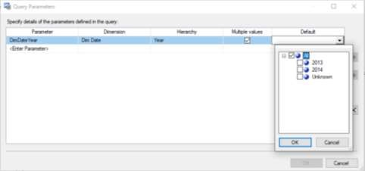

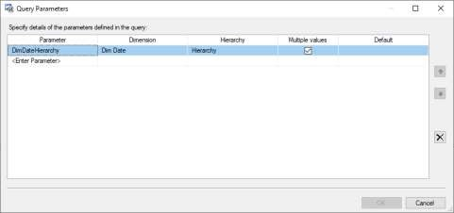

The entries will be shown on the screen.

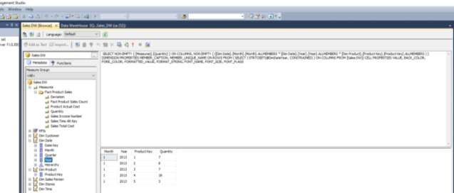

Right click on the file name and select Process.

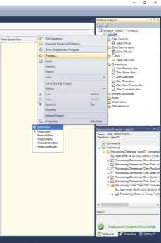

Select the file and click on Run.

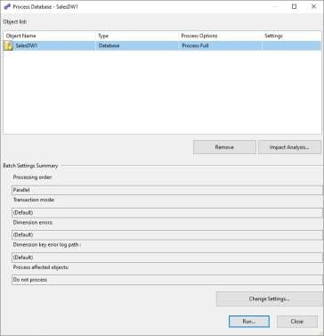

Process succeeded is the status.

